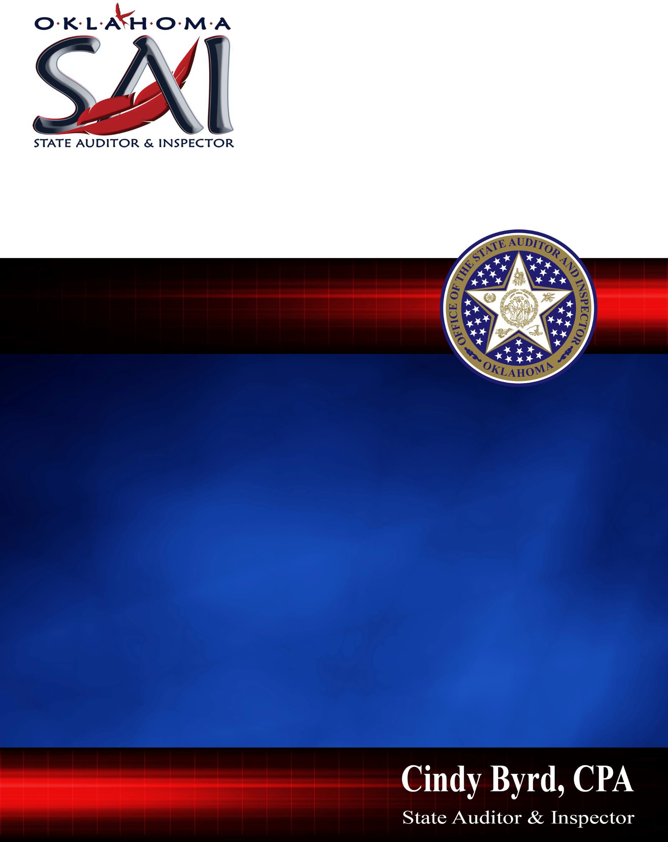

**Office of the**

**State auditor & inspector Fy2024**

**Annual report**

Office of the

State Auditor & Inspector FY 2024

Annual Report

*This publication is issued by the Office of the State Auditor & Inspector as authorized by 74 O.S. § 216. This publication has not been printed and is located on the agency website. This publication has been submitted in compliance with 65 O.S. § 3- 114 of the Oklahoma Statutes.*

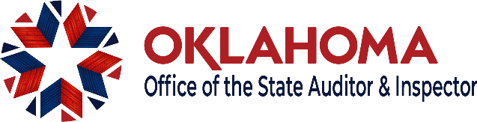

TO THE TAXPAYERS OF OKLAHOMA

As we close Fiscal Year 2024, our mission remains the same, to “hold government accountable.” Here are some of the remarkable things we accomplished to that end over the last year.

In 2024, we released the federally mandated State of Oklahoma Single Audit Report for fiscal year 2022. The audit covered more than $13 billion, most of which came from COVID relief funds. In analyzing how this money was spent, we found a systemic lack of oversight and accountability at the Office of Management and Enterprise Services (OMES). Of grave concern, our audit revealed that OMES took advantage of COVID to establish a new set of rules for vendor contracts. This action indefinitely suspended competitive bidding in Oklahoma and deprived citizens of financial safeguards. As a result, vendors profited from federal dollars, while many Oklahomans did not receive the help they needed. Ultimately, we identified over **$30 million** in federal questioned costs.

By request of the district attorney, the governor and others, our office is currently evaluating several high-profile state agencies and school districts. In late 2024 we will release audits of the **Oklahoma Tourism and Recreation Department**, embroiled in the ongoing controversy surrounding former state vendor, Swadley’s BBQ, and **Tulsa Public Schools**, wracked by an embezzlement scandal during the tenure of former superintendent, Deborah Gist. Keep an eye out for these and other upcoming audits, including:

* Oklahoma Turnpike Authority
* Office of Management and Enterprise Services

As inflation continues to impact Oklahomans, our dedicated team will demand transparency and accountability from government. We remain vigilant as the watchdog of taxpayer funds.

Sincerely,

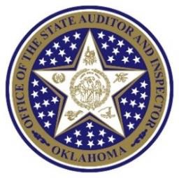



Cindy Byrd, CPA



|  |  |
| --- | --- |
|  | **CINDY BYRD, CPA**, is from Coalgate, Oklahoma. Cindy has 27 years of government auditing experience. Byrd was appointed the Director of County Audit Division in 2011 and eliminated a five-year backlog of county audits. In 2013, Cindy was appointed Deputy State Auditor and served in that capacity until 2019 when she was elected as Oklahoma’s 13th State Auditor and the first woman to hold the office. By the end of her first term, Cindy published more than 1400 audits some of which garnered statewide and national attention. Byrd was re-elected in 2022 and continues to advocate for responsible government. Cindy received the Dr. Tom Coburn Transparency in Government Award for mirroring his enduring legacy of championing government accountability and transparency.  State Auditor Byrd serves as:   * Vice-Chair, Oklahoma State Pension Commission * Member, State Board of Equalization * Chair, State Board of Equalization Sub-Committee * Commissioner, State School Land Commission * Auditor At-Large for the State Financial Officers * Foundation and a fellow of Club for Growth Fellowship   **LISA HODGES, CFE, CGFM**, is Deputy State Auditor for State Agency Auditing, Specialized Audits, Quality Assurance and Information Services. Lisa has been with the State Auditor & Inspector’s Office (SAI) since 1981. Lisa became a Certified Fraud Examiner in 1993 and qualified in 1996 as a Certified Government Financial Manager. She served as a National State Auditor’s Association (NSAA) Peer Review Team member from1998-2022. Lisa earned her Bachelor of Science degree in Accounting from Oklahoma State University in 1981. |



|  |  |
| --- | --- |
|  | **BRENDA HOLT, CPA**, is Director for the Forensic Audit Division. Brenda earned a Bachelor of Science in Accounting from East Central University and has been a Certified Public Accountant since 1987. During her 24-year tenure with SAI, Brenda has conducted county audits, college and university audits, state agency audits, and special audits of municipalities, school districts and other government entities. She works closely with prosecutors, governing boards, and the public in identifying fraud and waste of public funds by gathering the facts necessary to support successful prosecution of wrongdoers.  **MELISSA CAPPS,** Director of the Performance Audit Division (PAD), has 24 years of service with SAI. In her first decade with the SAI, she worked in the State Agency Audit Division, where she conducted audits across various state entities, including the Department of Human Services and the Health Care Authority. As Director of PAD, Melissa has overseen performance audits for state agencies such as the Department of Corrections, the Department of Wildlife Conservation, the Oklahoma School of Science & Mathematics, the Corporation Commission, and the Health Care Authority. In addition, she has led numerous operational audits across state agencies. Melissa has also directed several high-profile special investigative audits, including audits of the Department of Health, Stillwater Public Schools, and the Oklahoma Department of Tourism and Recreation. She holds a Bachelor of Business Administration in Finance from the University of Central Oklahoma. |
|  | **BILLY SWINDELL,** Director of the State Agency Audit Division (SAAD), graduated in 1994 with a Bachelor of Science in Accounting from the University of Central Oklahoma. Billy has 30 years of experience in the auditing industry, with 28 of those years at SAI. Billy joined SAI as an auditor and was promoted to Supervisor in 2005. Shortly thereafter, in 2007, he was promoted to Manager and later advanced to Deputy Director in 2015. Most recently, Billy earned the role of Director. Throughout his career, Billy has audited about every major program at the State of Oklahoma ACFR and single audit levels (State of Oklahoma, OMES, OHCA, OSDH, OSDE, DHS, DOC, DPS, DMHSAS, OST, OESC, and ODOT). Over the last 10 plus years Billy has overseen the State of Oklahoma’s Annual Comprehensive Financial Report (ACFR). As Director, Billy manages a staff of roughly 30 individuals who are responsible for auditing the ACFR, along with the single audit of federal expenditures for numerous agencies. |



|  |  |
| --- | --- |
|  | **MARK HUDSON, CPA, CGMA**, is Director of the Specialized Audit Division. He has more than 34 years of governmental auditing experience including oil and gas, horse racing and gaming. Mark graduated from East Central University with a Bachelor of Science in Accounting. As a Certified Public Accountant, Mark is a member of both the Oklahoma Society of CPAs and the American Institute of CPAs. |

|  |  |
| --- | --- |
|  | **CINDY WHEELER, CPA,** Director of Quality Assurance, began her tenure with the State Auditor’s Office in 2004 and was promoted to Audit Supervisor in 2006, and to Audit Manager in 2008. In 2012 Cindy assumed responsibility over the Quality Assurance Division. Cindy is a Certified Public Accountant, graduated from the University of Central Oklahoma in Edmond with a Bachelor of Science in Accounting, and earned a Master of Business Administration from Oklahoma Christian University in 2002. Cindy plays a pivotal role in ensuring our audits and audit reports comply with government auditing standards. She has served as a National State Auditor’s Association (NSAA) Peer Review Team member since 2013 and is the liaison with NSAA for SAI’s peer reviews. |
|  | **MICK DODSON, JD**, Director of Compliance, joined the SAI in 2011 and is the senior investigator. He is a graduate of the FBI Academy and a former special agent, and he is certified as a meetings/records legal instructor. He has a juris doctorate degree with a public-policy certification and awards in administrative law and professional responsibility, and he is a member of the Bar Association. He served on the city council of his hometown and interned in the district attorney’s office of a populous county. He has a bachelor’s degree in political science and journalism with a public-  relations emphasis. |

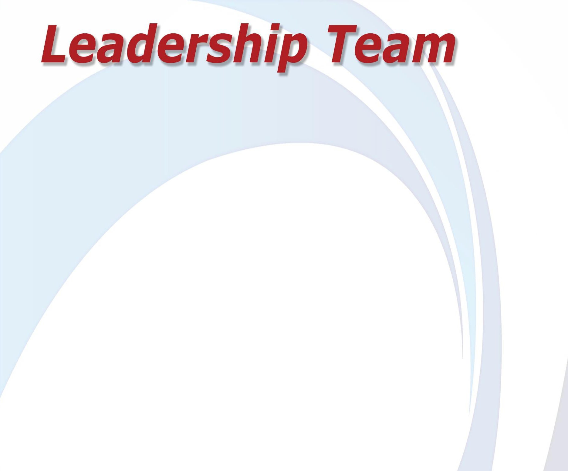

|  |  |
| --- | --- |
|  | **MARLA LATHAM, CGFM,** Audit Manager, County Audit Division, joined SAI in May 1984 after graduating from East Central University with a Bachelor of Science degree in Accounting. She holds the professional Certified Government Financial Manager title awarded by the Association of Government Auditors. In 1988, Marla took an Accounting Manager position with the Tarrant County Clerk’s Office, in Fort Worth, Texas and returned to Oklahoma and SAI in 2003. In all, Marla has more than 25 years of service for the state on behalf of taxpayers. Marla serves as the audit manager at the Oklahoma City Regional  District office overseeing Oklahoma County’s Annual Comprehensive Financial and Federal Audit along with other counties in central and north- central Oklahoma. |

|  |  |
| --- | --- |
|  | **RICKY BRANCH, MBA,** Audit Manager, County Audit Division, earned his Bachelor of Science degree in Accounting from Cameron University in Lawton and a Master of Business Administration from Oklahoma City University. He joined the agency in 1990 and has been an integral part of the County Audit Division during his 34-year tenure with SAI. Ricky serves as the Audit Manager at the Duncan Regional District office and oversees audits in 23 counties in the southwest quadrant of Oklahoma. |
|  | **JOHN BROWNELL,** Audit Manager, County Audit Division, earned his Bachelor of Business Management from St. Gregory’s University in Shawnee. John joined the County Audit Division in 2006 as an auditor. In 2011, John was promoted to Audit Supervisor. During his tenure, he has conducted a variety of audits including investigative, performance, and financial statement audits. During his time as an Audit Supervisor, John was an integral part of planning and conducting Oklahoma County’s Annual Comprehensive Financial Report and its federal single audit of federal expenditures. In May of 2022, John earned the role of Audit Manager of the Ada Regional Office District and directs audits in 13 Oklahoma counties in East-Central Oklahoma. |



|  |  |
| --- | --- |
|  | **KERRI CARTER,** Audit Manager, County Audit Division, is a 1990 graduate of the University of Central Oklahoma with a Bachelor of Arts degree in Education. She joined the County Audit Division staff in 1994 and has 30 years of government auditing experience. Kerri hails from Green Country and oversees audits in nine northeast Oklahoma counties from the Tulsa Regional District office. Kerri manages Tulsa County’s Annual Comprehensive Financial Audit and she and her team regularly conduct federal single audits for counties in her district. |
|  | **JESSIE MORRIS,** Audit Manager, County Audit Division, graduated from Southwestern Oklahoma State University in 2005 attaining a Bachelor of Business Administration degree in Accounting. Prior to joining SAI in 2009, Jessie audited various banks and a publicly traded trucking company. Since joining SAI, Jessie quickly earned the role of audit manager and directs audits in 17 northwest and north-central Oklahoma counties from the Weatherford Regional District office. |
|  | **DARLA ELLIS, CIA, CFE,** Audit Manager, Circuit Engineering District/County Audit Division, started as an entry level auditor in 2001 while still in college. She would earn her Bachelor of Science degree in Accounting from East Central University in Ada in 2002. A Certified Internal Auditor and a Certified Fraud Examiner, Darla is on the frontline of safeguarding public assets. She oversees statutorily mandated audits of the Circuit Engineering Districts across Oklahoma. Additionally, she directs audits in the southeast region of Oklahoma covering 6 counties. |



|  |  |
| --- | --- |
|  | **MELISSA LAFFOON,** Audit Manager, District Attorney/EMS Audit Division, began her career with the State Auditor’s office in 2007 in the County Audit Division. She earned her Bachelor of Science Business Administration degree in Accounting from Northeastern State University in 2008. During her tenure with the agency, she has conducted several types of audits including, County financial statement, investigative, Emergency Management Service, District Attorney, and federal single audits. She was promoted to County Audit Supervisor in 2011, where she was responsible for the audit of seven Oklahoma Counties, and most recently promoted to Audit Manager over the District Attorney/EMS Division in September 2023. Her focus will be primarily on overseeing the audit of the state’s 27 District Attorney offices and 65 Emergency Medical Service (EMS) Districts.  **CHERYL WILSON, CFS,** is the Manager of the County Management Service Division. Cheryl began her tenure with SAI in 1994, previously serving as a county auditor and as an information systems auditor. Cheryl earned her Bachelor of Science degree in Accounting from East Central University, Ada, in 1996 and is a Certified Fraud Specialist (CFS). She works closely with county officials and with the Oklahoma State University – County Training Program in both assisting with application of various statutes and auditing standards, as well as training on these topics.  **NANCY GRANTHAM,** State Board of Equalization/ Estimate of Needs/ Annual Budgets Executive Specialist, joined the agency in 1986 and was recently recognized for 37 years of service to Oklahoma taxpayers. Nancy is the administrative assistant to the Board of Equalization and works with its subcommittee on ad valorem compliance by counties. She works directly with the Oklahoma County Assessors Association and other county officials. Nancy was part of the team responsible for creating the online electronic Estimate of Needs for county government and school districts. She also oversees the receipt and review of more than 1200 public budgets. |

# THE AGENCY

The Office of the State Auditor & Inspector (SAI, the office) was created by the Oklahoma Constitution with the duty to examine the state and all county treasurers’ books, accounts, and cash on hand, stipulating that SAI shall perform other duties as may be prescribed by law. As such, the State Legislature has expanded the agency’s role and responsibilities over the years.

The intent was to create an independent state officer who would review how tax dollars were spent. For more than 11 decades, taxpayers have come to know the agency as its watchdog.

The State Auditor is a statewide elected official. The agency is part of the executive branch of state government which has the Governor at its top. Despite its appearance as being part of the Governor’s oversight, SAI remains separate from other executive branch agencies whose directors are largely appointed by the Governor.

Cindy Byrd, the 13th State Auditor & Inspector, is in the second year of her second four-year term, having first taken office in January 2019. This document is a report on Fiscal Year 2024.

SAI consists of six key divisions conducting different types of government audits of public entities. These divisions are the:

* State Agency Audit Division
* County Audit Division
* Performance Audit Division
* Forensic Audit Division
* Specialized Audit Division
* Information Services Division

The function and roles of these groups are detailed later in this report.

In many ways, SAI is organized like private sector accounting firms that also conduct government audits. The office derives about 30 percent of its funding from appropriated dollars, with the remainder of the budget funded by billing public entities for the actual cost of their audits, at rates that are considerably less than the hourly rates of our private sector counterparts.

Including the State Auditor, SAI has 103 audit professionals involved in the audit process with over 1200 years of combined auditing experience with the office. Over the last decade, only staff with audit-related degrees or expertise in certain fields have been added to our ranks.

Our audit professionals include:

* 11 Certified Public Accountants
* 2 Certified Internal Auditors
* 1 Certified Information Systems Auditor
* 6 Certified Fraud Examiners
* 3 Certified Government Financial Managers
* 3 IT Specialists
* 2 Certified Government Auditing Professionals

## SAI MISSION

Our mission is to “hold government accountable.”

With that in the forefront, SAI has focused on a dual-purpose role during Cindy’s tenure as State Auditor. In addition to our primary role of protecting taxpayers by monitoring how public entities both receive and spend public funds, SAI has established itself as the go-to agency in assisting the Governor and state lawmakers by obtaining information critical to the responsibilities of each.

This matters because SAI is the only agency in the state that consistently examines how tax dollars are spent, the effectiveness of various programs, and how efficiently government services are delivered at both the state and county level. This data and its application significantly contribute to meeting the Governor’s goal of making Oklahoma a Top 10 state.

Municipalities, school districts, public trusts, and public authorities are audited by private sector accountants or firms and not the State Auditor’s Office. Each public entity’s auditor is required to upload the completed annual financial statement audit report through the agency’s online portal for publication on our website.

# THE SPECTRUM OF AUDITS

There are many kinds of audits. They range from those that primarily look at an entity’s financial statements to the type that takes a deep dive into an entity’s financial records, programs, procedures, personnel, and other matters.

When many people hear that an entity has been audited, they generally think it has experienced a thorough going over. Most audits, however, are not the “turn over every rock” kind of examination to identify fraud, embezzlement, or other wrongdoing. Each type of audit serves its own unique purpose.

In our office, we conduct most audits under *Government Auditing Standards* created by the Government Accountability Office.

## Financial Statement Audit

This is the most common type of audit required by law that is conducted of public entities. As the name suggests, it is a review of an entity’s financial statements. Its intent is to give an opinion as to whether those financial statements fairly present an accurate picture of the financial condition of the entity.

The benefit of this type of audit is that it provides assurance that management has presented a “true and fair” view of an entity’s financial performance and position. It adds credibility to the reported financial position and performance of the entity.

A financial statement audit is not specifically designed to find fraud, embezzlement, or misuse of funds. However, if we do identify or suspect fraud, embezzlement, or misuse of funds during our audit, we report it to management and/or the appropriate officials.

To aid taxpayers and government officials, our agency thoroughly reviews internal controls which, if ineffective or nonexistent, place an entity at risk of fraud, waste, or abuse. We provide targeted recommendations for actions management can take to improve the internal controls within their agencies.

Our audits are a tool to both promote and create a better, more responsive government while improving the delivery of government services. In the end, we see our role as helping government officials do things right by putting in place certain practices and procedures to safeguard public funds, reduce the risk of fraud, and improve transparency and accountability.

To demonstrate accountability of our own office, we hire an outside accounting firm every year to conduct an independent financial statement audit of SAI’s financial records. This report is available at [www.sai.ok.gov](http://www.sai.ok.gov/).

## Performance Audits

A performance audit may contain a financial component, although its design is to evaluate the economy, efficiency, and effectiveness of government programs and functions with the goal of implementing improvements. It takes considerable planning and risk assessment. Once concerns are identified, the audit report offers recommendations to help the entity strengthen and enhance its programs, processes, and function.

In many ways, our objective analysis and recommendations initiate positive change in government operations, procedures, and delivery of government services.

Our office conducts this type of audit on request from the Governor, the chief executive officer of a governmental entity, or through a joint resolution of the legislature.

The agency currently has an annual contract with the Oklahoma Corporation Commission to conduct performance audits.

## Operational Audits

A type of performance audit, an operational audit looks at an entity’s operations as well as financial documents and internal controls. It seeks to determine whether certain safeguards are in place to ensure good stewardship of public funds.

Operational audits are performed on both state and county entities and have a different focus than a financial statement audit. These reports provide good information for public officials to use in complying with both statutory requirements and financial reporting obligations.

An operational audit may address many issues ranging from financial controls to a program or agency’s compliance with specific laws and regulations such as whether revenue was deposited in the correct fund as directed or expenditures from a certain fund were allowable.

## Agreed-Upon-Procedures

The least invasive and usually the most cost-effective review is the agreed- upon-procedures engagement or AUP. An AUP is limited in scope to specific procedures on a subject matter, and the auditor does not offer an opinion as a result of the review. While it is conducted in accordance with *Government Auditing Standards*, with this type of engagement, the procedures performed are agreed upon with entity management or dictated by state law.

## Forensic Audits

Forensic, investigative, or special audits represent a comprehensive examination process that pursues every allegation or detail. These audit reports often support prosecutors in uncovering evidence related to allegations of fraud or embezzlement.

Forensic audits are not required to follow the auditing standards that guide SAI’s other audit work but are limited to defined objectives and allegations.

A forensic audit typically includes review of an entity’s internal financial records, bank records, and other documents. A forensic auditor conducts numerous interviews and, often, follow up interviews during the fact- gathering process. This type of audit is regularly requested when fraud, embezzlement or misuse of public funds is suspected.

Forensic, investigative, or special audits must be requested by the Governor, the Attorney General, a local district attorney, a governing board, or by citizen petition. SAI does not have the constitutional or statutory authority to initiate these audits without a formal request.

## Statewide ACFR (Annual Comprehensive Financial Report)

This financial statement audit, conducted in accordance with *Government Auditing Standards* by our State Agency Audit Division, is critical to reviewing the expenditure of state and federal funds and maintaining the state’s bond rating.

The ACFR is prepared by the Office of Management & Enterprise Services and is audited by SAI.

The ACFR audit takes about six months and 21 auditors to complete. The audit reviews the financial transactions of public funds by state government and reported findings are most often due to the lack of internal controls or failure to follow established policies and procedures designed to safeguard public funds.

The ACFR contains a wealth of information about the State of Oklahoma, its government entities, and its people. The audit report is due by December 31st each year.

## The Statewide Single Audit

The team of auditors who audit the ACFR also conduct the single audit for Oklahoma. The audit is an intensive compliance review of the expenditures of specific federally funded programs and is a key factor in the consideration and determination of whether Oklahoma will continue to receive federal funds for those programs.

Breaking it down, the single audit is basically a review of the state’s stewardship in its expenditure of federal funds.

Many state and county entities depend on the flow of federal dollars to fund various programs that deliver government services that benefit Oklahoma residents from newborns to the elderly. In many instances, the state is required to match a certain percentage of federal funds received.

Findings of internal control deficiencies and discrepancies in the expenditure of federal funds or costs that are questioned by SAI are included in the final report. The issued report and its findings are thoroughly reviewed at the federal level to ensure the agency complied with the single audit reporting requirements. Findings are further reviewed to determine whether the federal agency accepts the corrective action plan of the agency or if additional action is necessary.

The single audit is required to be completed by March 31st of each year.

## Workpapers

Noted previously, workpapers are the effective equivalent of evidence – the result of fact-finding that is part of every type of audit. These financial records, interview notes, and other records are maintained electronically and are subject to the Open Records Act upon publication of an audit report.

Among our auditing responsibilities is to accurately determine fact from fiction. Findings included in our reports are fully supported by our workpapers.

## Peer Review

Every three years, the State Auditor’s Office undergoes a peer review conducted through its affiliation with the National Association of State Auditors, Comptrollers and Treasurers and its subunit, the National State Auditors Association.

A state audit shop either passes, passes with deficiencies, or fails. SAI has received a ‘pass’ rating every peer review since 2008. You can read the letter later in this report.

A team of auditors, our peers from other state audit shops around the country, spend a week reviewing audits we released over a 12-month period.

The group carefully reviews our audit reports for content, clarity, and the correct application of audit reporting standards.

The peer review team, as part of its review, examines our workpapers which should fully support any finding in an audit report. They determine whether we are following our policies and procedures, which incorporate auditing standards, and review our training records to ensure our staff meet the minimum training requirements set by *Government Auditing Standards*.

Our next peer review is scheduled for July 2026.

## TODAY’S AUDITS

Change is just as constant in the audit world as everywhere else in our professional and personal lives. Technological advances and software have evolved to support auditors in doing an even better job regardless of the type of audit being conducted.

Our office, too, has advanced to ensure its staff has the tools needed to work effectively and efficiently in today’s audit world.

For the most part, desktop adding machines, pencils and paper have been replaced with laptop computers, monitors, and electronic spreadsheets. Audit software can more accurately analyze in 30 minutes or less what once could require a laborious process by hand.

Data Analytics assist an auditor in identifying discrepancies in balance sheets, receipt and deposit records, and other financial documents to highlight anomalies that could indicate the existence of fraud and misuse of funds.

Our agency personnel are all equipped with laptops which enables an efficient shift to telework when offices are closed or whenever else it is necessary.

**Data Dumps**

As part of the audit work performed on counties, our Information Services Division regularly receives data dumps from a county’s accounting software provider. This data is sifted using our auditing software and then organized in a way that is useful to our staff conducting county audits.

This may seem like a simple thing, and with today’s technology, it arguably is. It is important to note here because it reduces audit time, which reduces audit costs, and enables a more efficient work product for county taxpayers.

**AGENCY DIVISIONS**

# STATE AGENCY AUDIT

Funding state government very much relies on the independence and quality of the reports conducted by this group of auditors.

In FY24, the legislature appropriated $12.6 billion dollars to various state agencies.

The amount of fieldwork that goes into both the Statewide Single Audit and the Statewide ACFR is extensive.

The management team within the State Agency Audit Division has been effectively working together for many years. The tenure of this group assures competence in the audit process, appropriate application of auditing standards, and impartial judgment on the proper expenditure of public funds.

### FY2023 ANNUAL COMPREHENSIVE FINANCIAL REPORT

We referenced this audit previously and expressed our position as to its significance. Our opinion was that the financial statements were fairly stated.

We did issue two reportable findings: one related to fraudulent Unemployment Insurance (UI) claims at the Oklahoma Employment Security Commission (OESC), and the other related to material misstatements per Statewide adjusting entries (999 entries) for the Office of Management and Enterprise Services.

The OESC finding was a repeat from FY20 through FY22, where OESC faced an enormous challenge as COVID caused a shutdown of the economy and put hundreds of thousands of our neighbors out of work. The surge in unemployment exploited the weaknesses of the decades-old claim filing system at OESC, allowing fraudulent unemployment claims that continued into FY23.

### In FY21, OESC established new processes and back-end technology procedures to identify and stop fraudulent claims, implemented safeguards for all ACH transfers or fund transfers to personal bank accounts, and developed a UI Analytics and Reporting platform to improve claim processing efficiency and accuracy. These new safeguards helped to greatly reduce the amount of fraudulent UI claims in FY22 and FY23.

### FY2022 SINGLE AUDIT

As with the ACFR, the single audit is a noteworthy review of federal spending. It is a rigorous analysis to ensure, among other things, free school nutrition programs are funded, health care costs for retirees and the elderly are manageable, and supplemental programs remain in place to assist single parents with children, the disabled, and the disadvantaged. Federal agencies rely on the single audit to evaluate program compliance and effectiveness.

Typically, more than 50 percent of Oklahoma’s annual budget for government operation comes from federal revenue streams. The influx of CARES Act and ARPA funds significantly increased federal funding to the state.

In each of FYs 2021 through 2023, state agencies received approximately $14 billion in federal funds. That is about $4 billion more than FY20 due to funding to address COVID-19.

In FY23, it is estimated state agencies were on a similar spending track as in FY22 and the accountability of the expenditure of these funds will be provided by the annual single audit of the State of Oklahoma.

# COUNTY AUDIT

The County Audit Division (CAD) is made up of about 50 audit personnel living across the state and operating out of five regional district offices.

The geographical location of these auditors matters because they are busy conducting audits in the state’s 77 counties.

CAD has five district offices located across the state to minimize travel and remain efficient with transportation costs.

CAD issued 251 audit reports in FY24 or about 76% of all audits conducted by SAI in FY24.

These audit reports included treasurer reviews, financial statement audits of counties, compliance audits of emergency medical service districts and district attorney offices, and turnover audits of any outgoing county official. This division also audits the Annual Comprehensive Financial Reports on the financial records of Oklahoma County and Tulsa County.

SAI conducts an annual financial statement audit of each of the other 75 county governments in two-year increments. These audits include the operations of the three county commissioner districts, and the county clerk, assessor, treasurer, court clerk and sheriff’s offices.

The cost of these audits is paid through a one-tenth of one mill property tax assessment to county property owners. For about one-third of counties, the funding for its annual audit is insufficient to cover the actual cost of the audit.

These audits provide county residents valuable information as to how their tax dollars are being spent.

### SINGLE AUDIT FOR COUNTIES

A single audit is included within a county's financial statement audit when the requirement for a single audit is triggered (after a county’s federal expenditures meet or exceed the $750,000 annual fiscal year threshold).

As with the flow of federal funds to the state, a single audit is critical for the payment of federal dollars to a county that qualifies for disaster relief, law enforcement grants, and other federal funds available at the county government level. The feedback provided in our single audit reports assist the counties with compliance required by these federal resources.

Among the findings we typically identify in a county financial audit with a single audit component are related to inadequate internal controls and subrecipient monitoring.

In FY 2023, 52% of financial audits published included a single audit. For FY 2024, 35% of financial audits published included a single audit. We expect that percentage to be higher in the audits performed during the FY 25 audit cycle.

Alternative Compliance Examination (ACE) engagements will be performed for many of the counties that received Coronavirus State and Local Fiscal Recovery Funds as an alternative to a single audit as allowed by the 2022 OMB Compliance Supplement. However, even as these engagements require reduced audit procedures, many of these counties require a single audit infrequently, or may have never required one, and this will represent a significant challenge to the counties as well as the audit teams.

It is important to note the amount, based on millage, that counties budget for and are required to pay for their audits typically does not cover the cost of just the financial statement audit and will surely not cover the cost of the additional single audits that will be required in the next few years.

### AMERICAN RESCUE PLAN ACT FUNDING FOR COUNTIES

The $65.1 billion in direct aid nationally to counties was included in the American Rescue Plan Act (ARPA). Oklahoma’s 77 counties will share the $767,430,155 sent to the state.

The funding comes with restrictions for its use and SAI has been working with the Association of County Commissioners of Oklahoma and directly with county officials on the reporting requirements and project eligibility limitations.

The Top 10 county recipients in the state will share about 61% of all funds coming to Oklahoma. Most of the funding roughly follows the major metropolitan corridor stretching along I-44 from Lawton to Claremore.

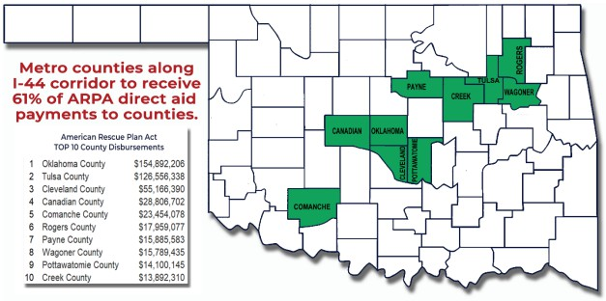

Oklahoma County leads the list with $154.89 million followed by Tulsa County at $126.56 million. The amount of aid drops significantly from Cleveland County at $55.17 million to Creek County at $13.89 million.

The funds became available in May 2021 and must be used on eligible projects, or the funds encumbered for future projects by December 31, 2024.

### CIRCUIT ENGINEERING DISTRICTS

In FY21, State Auditor Byrd established the CED/Southeast Audit Division within the Ada Regional District office. The division’s creation was in response to legislation requiring the State Auditor to annually audit Oklahoma’s eight Circuit Engineering Districts (CEDs).

Of the 77 counties in Oklahoma, 76 counties choose to participate with the CEDs to obtain civil engineering services and program management services for road projects.

Lawmakers want to know if CEDs are operating efficiently, complying with various statutes in the receipt and expenditure of county road funds, and if each is properly safeguarding public assets.

During FY24, the CED/Southeast Audit Division developed and presented a uniform chart of accounts and standard operating procedures manual to promulgate uniform financial reporting among the CEDs and published nine CED audits.

# COUNTY MANAGEMENT SERVICES & STATE BOARD OF EQUALIZATION DIVISIONS

County Management Services provides assistance to county officials through consultation and training services.

The division works closely with the OSU County Training Program (OSU-CTP) to develop and present training classes for county officials and employees. Staffed by one full-time employee and one part-time contractor, the division offers technical assistance regarding budgetary and accounting matters and prescribes accounting forms and procedures for use by county government.

The Board of Equalization Division along with input from the OSU County Training Program and experienced budget makers, updated and improved the prescribed uniform electronic estimate of needs form for county government. Much credit goes to county software providers, county officials, private sector accountants, and OSU-CTP for making this effort a reality.

Meanwhile, as noted previously, more than $767 million in ARPA funds is flowing directly to Oklahoma counties. The County Management Services Division Manager is a key contributor to providing guidance to county officials regarding the appropriate use of state and local fiscal recovery funds.

# PERFORMANCE AUDIT

Performance auditors look at an entity’s various programs, policies, procedures, communication, delivery of services, and other concerns.

A performance audit may be targeted to conduct a thorough review of a specific program or more general to review processes for receipting and expending funds.

Operational audits are routinely performed in compliance with statutory auditing requirements of state agencies. These entities are on a rotation and subject to audit every two years.

Considerable planning goes into each of these audit types, to ensure any important risks are identified and the matter under review is being fully addressed by the audit.

The Performance Audit Division completed 17 operational, and one performance audit in FY24.

## Operational Audits

* Secretary of State
* Bureau of Narcotics
* DEQ – Waste Tire Recycling
* Labor Commission
* Horse Racing Commission
* Breeding Fund (Horse Racing Commission)
* Alcohol Beverage Licensing Enforcement (ABLE) Commission
* Oklahoma Juvenile Affairs
* Oklahoma Tax Commission
* Oklahoma Cooperative Circuit Engineering Districts Board
* Council on Law Enforcement Education and Training
* Department of Corrections
* Oklahoma Education Quality and Accountability
* Board of Nursing
* Attorney General
* Medicolegal Investigation Board
* Oklahoma Energy Resources Board

## Performance Audits

* ODOT – Size and Weights Division

# FORENSIC AUDIT

Forensic audits look beyond the financial condition of a governmental entity and seek to determine the underlying state of the entity. The forensic audits carried out by our office primarily focus on identifying corruption and fraud perpetrated by public officials and employees.

Forensic audits often begin with a complaint or allegation concerning the lack of oversight of the finances of a public organization. Forensic audits are also initiated when citizens of a community or constituency express concerns or dissatisfaction with their local government. In such cases, these audits can be requested through the citizen petition process.

The citizen petition process is defined in statute and requires 10% of the registered voters in the community or constituency area (i.e., county, school district, etc.) to sign a petition requesting an audit of the governmental unit. These audits can be challenging because, more often than not, they involve small cities or towns, and the citizens are emotionally invested in the process.

The Forensic Division published eight forensic audits in FY24 and continued to assist law enforcement and the Attorney General’s Office in numerous prosecutions. The prosecution of the EPIC Charter Schools investigation, a five-year long process, continued to work its way through the legal system, with the next court hearing scheduled in December 2024. The case includes multiple charges of embezzlement and racketeering against the two owners of the school’s former educational management organization and their chief financial officer and involves the potential for recovery of millions of dollars of taxpayer funds.

Criminal cases also continue in the courts against the former superintendent of the Justice Alma Wilson Seeworth Academy with a plea hearing scheduled for January 2025. The forensic audit of Seeworth Academy revealed fraudulent transactions totaling more than $250,000.

An investigation involving the Town of Boynton reached completion with a former employee of Boynton being found guilty in a jury trial in April 2024. Guilty pleas were also entered in the criminal cases of the Town of Jones and the Payne County Sheriff’s Office. From these three cases, a combined total of $275,000 in restitution was claimed for the State. New charges were filed in three additional cases during 2024, the Town of Coyle, the City of Talihina, and the Love County Treasurer, all with court dates pending.

# SPECIALIZED AUDIT

This group of auditors primarily conducts audits under contract with other public entities.

The Oklahoma Horse Racing Commission contracts with our office to audit all wagering activities at the state’s three racetracks and the off-track wagering facilities it licenses.

The Commission also contracts with us to monitor all gaming activities occurring at two of the state’s racetracks it licenses. Staff audit and track all gaming revenue to ensure an accurate accounting of proceeds designated for state education funds at the Oklahoma Tax Commission.

The U.S. Department of the Interior (DOI), through its Office of Natural Resources Revenue (ONRR), contracts with our office to conduct audits of mineral royalties derived from federal lands in Oklahoma. The state receives 50 percent of all royalty dollars collected because of an audit.

State funds are not expended on this agreement as the office is completely reimbursed for the audit services it provides.

A recent review by ONRR looked at agency costs, its performance workplan progress, IT security requirements, and equipment. In all instances, the review found SAI had appropriately adhered to its agreement requirements.

# INFORMATION SERVICES

The independence required by *Government Auditing Standards* demands that auditors must remain independent in both mind and appearance from the entities we audit. While many state agencies’ information technology (IT) and information services divisions (ISD) were consolidated under OMES Information Services Division, SAI has retained its IT staff and auditors to preserve its independence and to meet *Government Auditing Standards*.

SAI’s ISD performs an outstanding service in keeping our networks, equipment, and auditors in working order. ISD supports the electronic auditing software and other technologies that are powerful tools in providing taxpayers with transparency and accountability. ISD also plays a critical role in reducing both downtime and audit time – all of which improve efficiencies. For FY24, ISD resolved 3,075 helpdesk tickets from staff.

The agency completed its fourth successful independent IT Security assessment and is in the process of its fifth assessment conducted in accordance with the National Institute of Standards and Technology (NIST) cyber security framework. NIST has established a set of standards for security controls of an entity’s information systems. Compliance is critical to ensuring the agency’s IT infrastructure is protected and its policies and procedures are implemented correctly.

National State Auditors Association

*An Affiliate of NASACT*

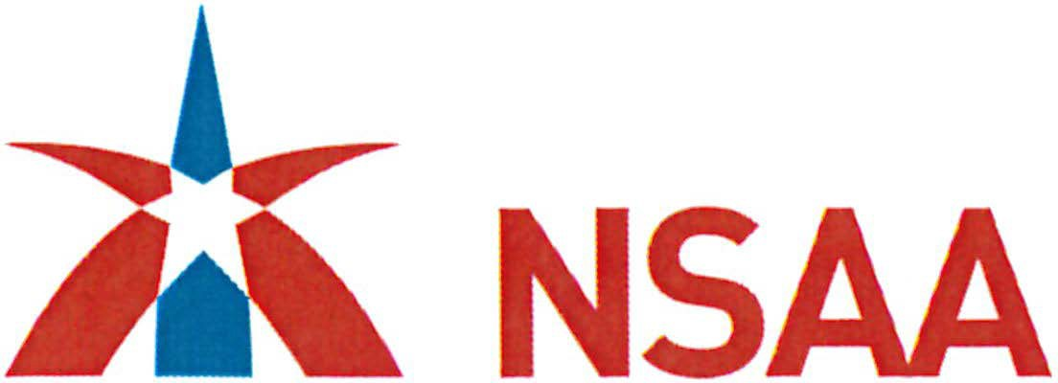Headquarters Office

449 Lewis Hargett Circle. Suite 190 Lexington. KY 40503-3590

P (859) 276-1147, F (859) 278-0507

[www.nasact.org](http://www.nasact.org/)

Washington Office The Hall of the States

444 N. Capitol Street, NW, Suite 422 Washington, DC 200001

P (202) 624-5451, F (202) 624-5473

**PEER REVIEW REPORT July 21, 2023**

The Honorable Cindy Byrd, CPA

State of Oklahoma Office of the State Auditor & Inspector 2300 N. Lincoln Blvd, Room 123

Oklahoma City, OK 73105

We have reviewed the system of quality control of Oklahoma Office of the State Auditor & Inspector (the office) in effect for the period July 1, 2022 through June 30, 2023 and for the 2021 State of Oklahoma ACFR audit released on January 26, 2022. A system of quality control encompasses the office's organizational structure and the policies adopted and procedures established to provide it with reasonable assurance of performing and reporting in conformity with applicable professional standards in all material respects. The design of the system and compliance with it are the responsibility of the office. Our responsibility is to express an opinion on the design of the system and the office's compliance with the system based on our review.

We conducted our review in accordance with the policies and procedures for external peer reviews established by the National State Auditors Association (NSAA). In performing our review, we obtained an understanding of the office's system of quality control for engagements conducted in accordance with professional standards. In addition, we tested compliance with the office's quality control policies and procedures to the extent we considered appropriate. These tests covered the application of the office's policies and procedures on selected engagements. The engagements selected represented a reasonable cross-section of the office's engagements conducted in accordance with professional standards. We believe that the procedures we performed provide a reasonable basis for our opinion.

Our review was based on selective tests; therefore it would not necessarily disclose all design matters in the system of quality control or all compliance matters with the system. Also, there are inherent limitations in the effectiveness of any system of quality control; therefore, noncompliance with the system of quality control may occur and not be detected. Projection of any evaluation of a system of quality control to future periods is subject to the risk that the system of quality control may become inadequate because of changes in conditions, or because the degree of compliance with the policies or procedures may deteriorate.

In our opinion, the system of quality control of the Office of the State Auditor & Inspector in effect for the period July 1, 2022 through June 30, 2023 and for the 2021 State of Oklahoma ACFR has been suitably designed and was complied with during the period to provide the audit organization with reasonable assurance of performing and reporting in conformity with *Government Auditing Standards* in all material respects. Audit organizations can receive a rating of *pass, pass with deficiency(ies},* or *fail.* The **Oklahoma Office of the State Auditor** & **Inspector has received a peer review rating of *pass.***



